Pre-registration required:
Registrations received after February 2, 2019 will be on space available only.
Registration http://ews.swe.org/eyhstudent.html
Fee: $10.00 check or money order payable to
SWE-EWS
Fee includes all conference materials.
Sorry no refunds after February 2, 2019

Lunch: Pizza will be provided, or you may bring a non-perishable sack lunch with your full name and school printed on each side.
Check in: Check in begins at 8:15 a.m. on conference day for participants to pick up their packet and information. No confirmation will be sent prior to the event.
Contact:
eyhtricities@gmail.com

Dimple Patel, SWE-EWS
Megan Nims, ACS

Conference Schedule
8:15 8:45 a.m. Check-in
8:45 8:55 a.m. Opening
9:00 9:45 a.m. 1st Workshop
10:00 10:45 a.m. 2nd Workshop
11:00 11:45 a.m. 3rd Workshop
12:00 12:45p.m. Lunch, Keynote Speaker
12:45 1:00 p.m. Closing

Directions to Columbia Basin College
From I-182 take Exit 12B – N 20th Ave Exit
Turn left if coming from Richland. Turn right if coming from Walla Walla. Take a Left on W. Argent Rd. Turn left at the first light onto Saraceno Way. Registration will be in the H building/Gjerde Center

THIS IS WOMEN’S WORK!
Workshop Sessions
Each participant will attend 3 hands-on workshops the day of the conference. Please note, EYH will do our best to accommodate student workshop preferences, but space is limited. Workshops will be scheduled on a first come, first served basis.

Notice
Do not bring valuables; EYH workshop is not responsible for the loss of or damage to any valuables.
This activity is not sponsored or endorsed by Pasco, Kennewick, or Richland School District
Example Sessions, for a complete list please see the website.
A Day in the Life of a Project Manager- Managing Constraints in Scope, Time, Money
Project managers work to manage projects from start to finish within time, money and scope constraints. Learn hands on how to plan and manage a project to build a public park.

Digging Deep into Hanford Contamination
This workshop will help students learn more about Hanford's contamination problem and how scientists are using soil to slow down pollution to groundwater and the Columbia River. Students will learn about the different types of soil and how their properties might control the transport of pollutants.

Fun with Fossils
Did you like learning about dinosaurs in school? Have you ever wondered what geologists can learn from fossils? Put on your field hat and go on a simulated fossil dig in the classroom to experience what being a palaeontologist is like.

Secret Rainbows: the Chemistry of Plants
Separate plant pigments from leaves and see how plant pigments change in different liquids

Alcohol in the Body
A presentation on alcohol in the human body: how it affects us, how it’s detected in our lungs for a breathalyser, and how long it takes for alcohol to leave the body.

Do You Know the Law? Game Show and Debate.
Students will be split into teams to participate in two activities. In the first activity, Teams will answer questions about the law to earn point for their team. In the second activity, students will debate.

Physicist
What’s it actually like being a scientist? It’s challenging, interesting, and every day is a little different. We will do some doing some problem solving, physics, inventing, and more; learn how these kinds of skills help with real world problems.

Knowing the Language of Your Brain
Would you like to learn how to use language to develop a smarter brain? In this workshop you will participate in 7 activities for strengthening your thinking skills.

Laboratory Science in Medicine
Have you ever wondered, "What happens when a doctor orders a test to be sent to the lab?" Now is your chance to experience some of the science behind the testing done in a real medical laboratory. Find out how those who work in medical laboratories provide the information the doctor needs to make or keep you well.

What's the deal with dirt?
Get dirty exploring soil health and learn how healthy soils support sustainable farming. We will examine physical and biological properties of soil and learn what makes a soil healthy.

Nanotechnology in our lives
Scientists manipulate matter to obtain nanomaterials that can be used in many applications: medicine, cosmetics, etc.. Let’s learn how small one nanometer is and classify objects according to their sizes.

Register Today!

Registration Deadline: February 2, 2019

Registration is online at:

http://ews.swe.org/eyhstudent.html

Registration Check List:

On the registration website, please complete the following:
- Complete the Parent Signature Liability Form
- Determine how you will pay the registration fee:
  - Pay the $10 registration fee via PayPal
  - Request a Financial Need Scholarship, via the Scholarship Application
  - Bring a check to the event ($10 made out to SWE-EWS).
  - Attend as a MESA Student

Questions? Concerns? Contact EYH:
eyhtricities@gmail.com

Expanding Your Horizons
is sponsored by:
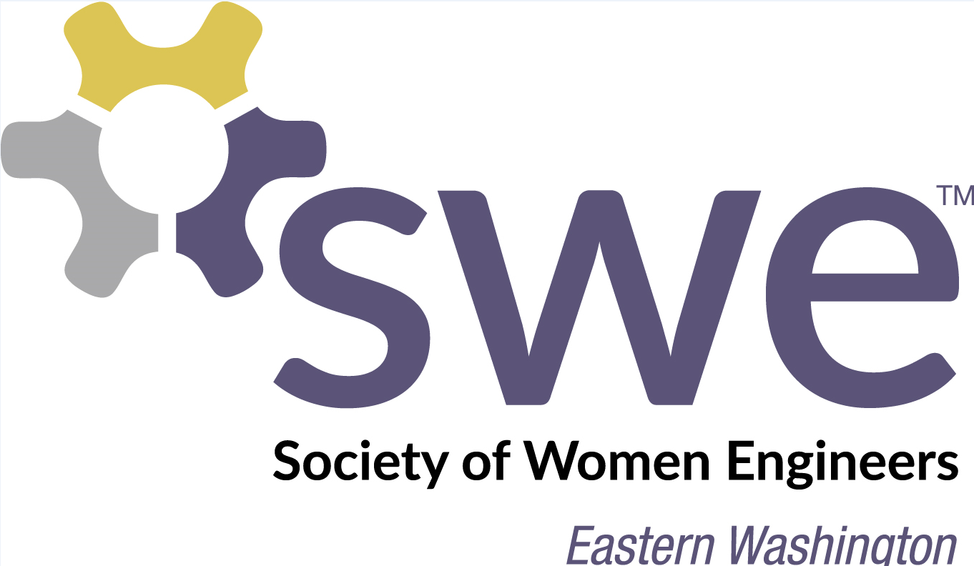

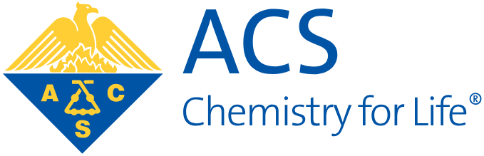

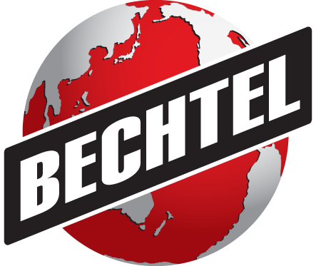

And is presented by:
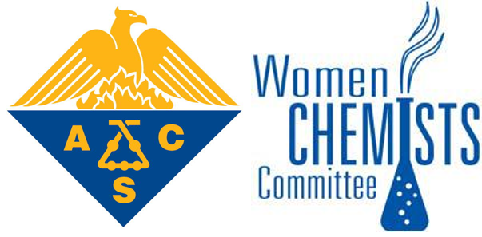
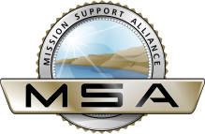
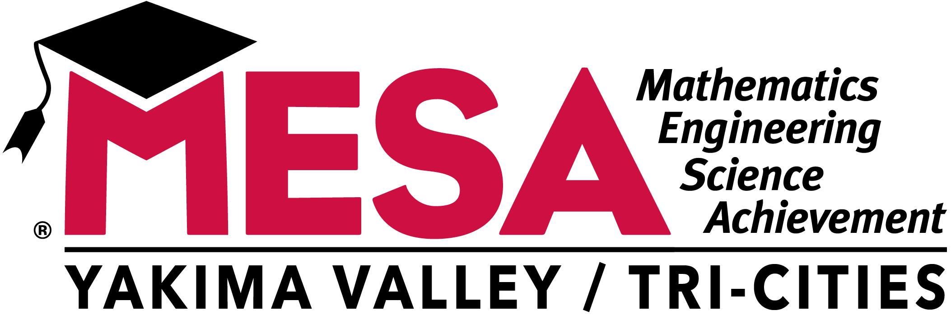

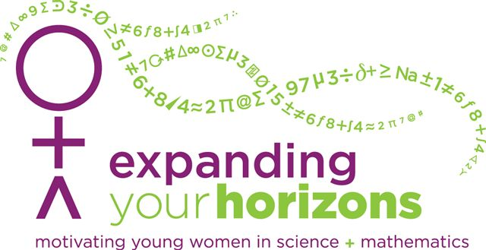

A conference with hands-on workshops for girls in grades 6-8 presented by women in traditional and nontraditional careers.

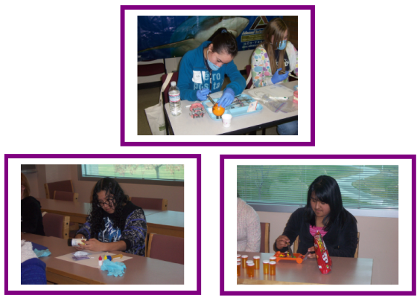

February 9th, 2019

8:15 a.m. to 1:00 p.m.

Columbia Basin College
2600 N. 20th Ave, Pasco, WA 99301

Website: http://ews.swe.org/eyhstudent.html

